MUJTABA SHAHID FAIZI
BSCS-5A
#131818
OS LAB 1

TASK 1:

echo "Enter your name?"
read a
echo "Enter your batch number"
read b
echo $a
echo $b

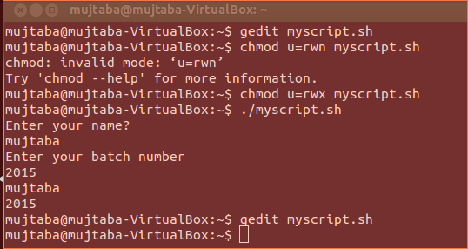

Task 2:
echo "enter a number"
read a
for b in {1..10}
do echo $a"*"$b"=" `expr $b \* $a`
done
exit 0

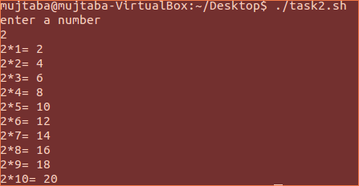

Task 3:

echo "Enter Source folder"
read dir_s
echo "Enter the destination folder."
read dir_d
ls $dir_s
while true
do
echo "Enter file name to copy, enter exit or press CTRL + C to stop."
read file_name
if [ "$file_name" == "exit" ]
then
break
fi
echo "Copied"
cp $PWD/$dir_s/$file_name $dir_d
done

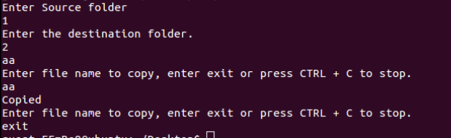

Task 4:

echo "Enter File name"
read fname
echo "Number of Words"
wc -m $fname
echo "Number of Lines"
wc -l $fname

